# Question 01

## Handwork

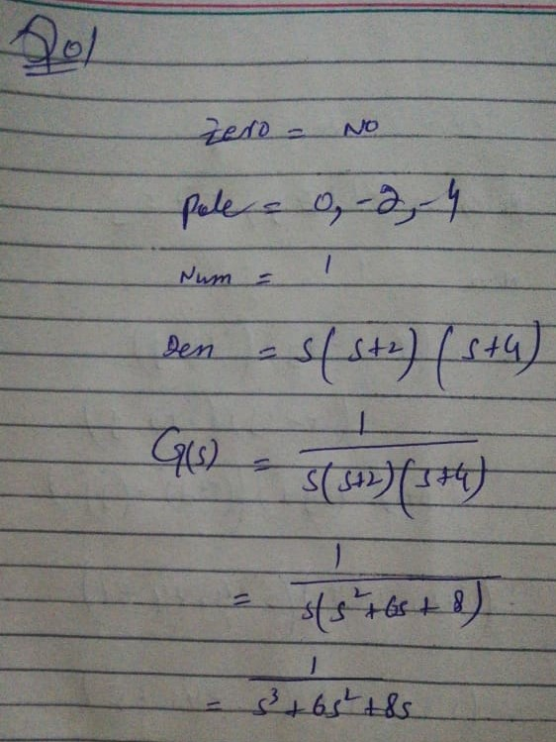

## Code

clc

clear all

close all

num=[1];

den=[1 6 8 0];

tf_=tf(num,den)

rlocus(tf_)

## Plot

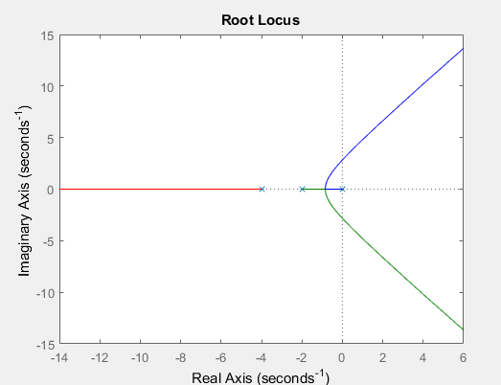

## Output

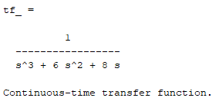

# Question 02

## Handwork

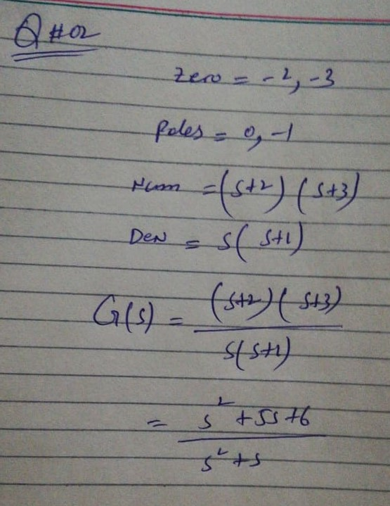

## Code

clc

clear all

close all

num=[1 5 6];

den=[1 1 0];

tf_=tf(num,den)

rlocus(tf_)

## Plot

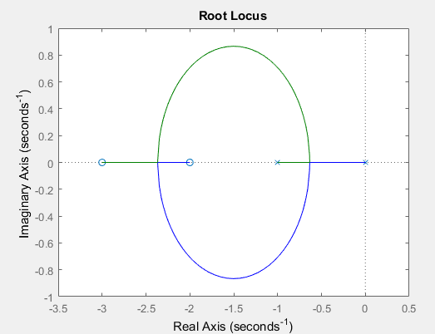

## Output

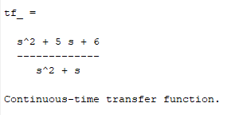

# Question 03

## Handwork

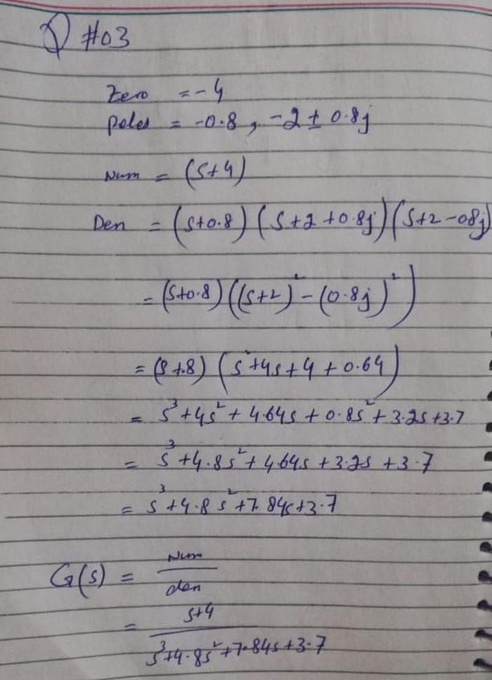

## Code

clc

clear all

close all

num=[1 4];

den=[1 4.8 7.84 3.7];

tf_=tf(num,den)

rlocus(tf_)

## Plot

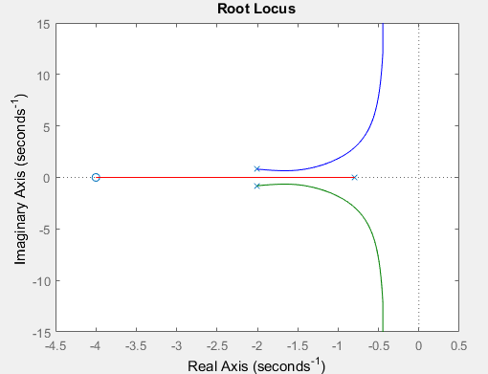

## Output

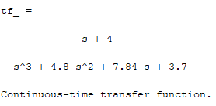

# Question 04

## Handwork

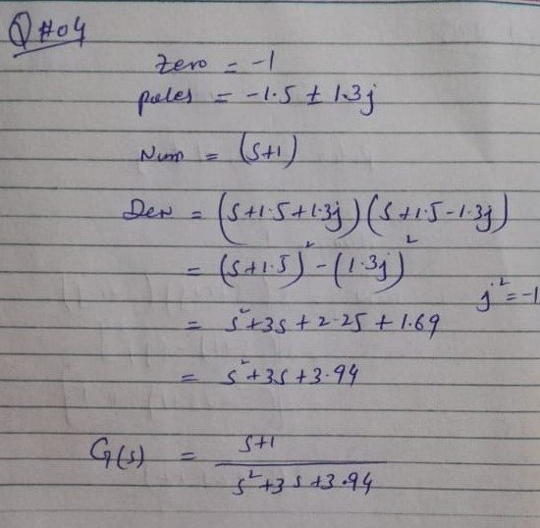

## Code

clc

clear all

close all

num=[1 1];

den=[1 3 3.94];

tf_=tf(num,den)

rlocus(tf_)

## Plot

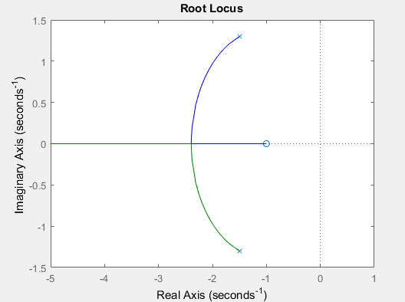

## Output

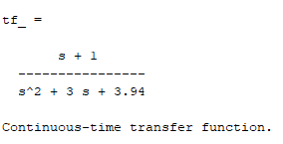

# Question 05

## Handwork

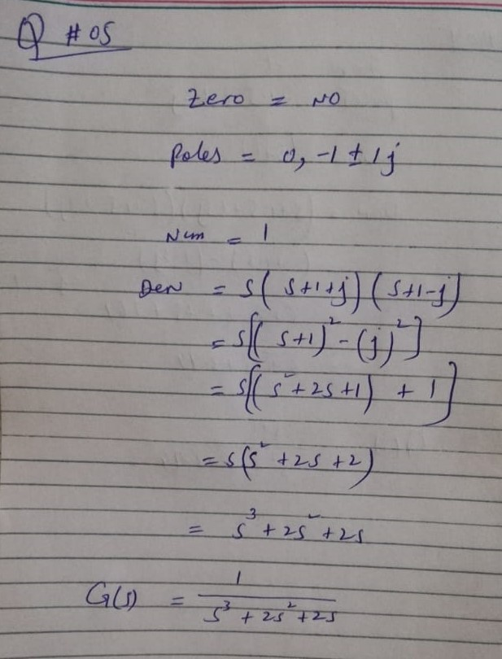

## Code

clc

clear all

close all

num=[1];

den=[1 2 2 0];

tf_=tf(num,den)

rlocus(tf_)

## Plot

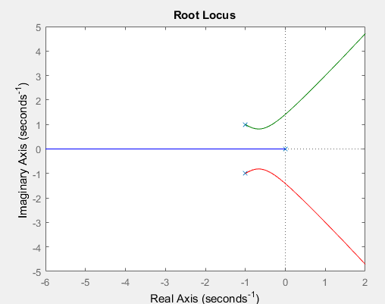

## Output

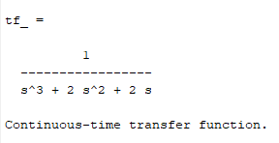

# Question 06

## Handwork

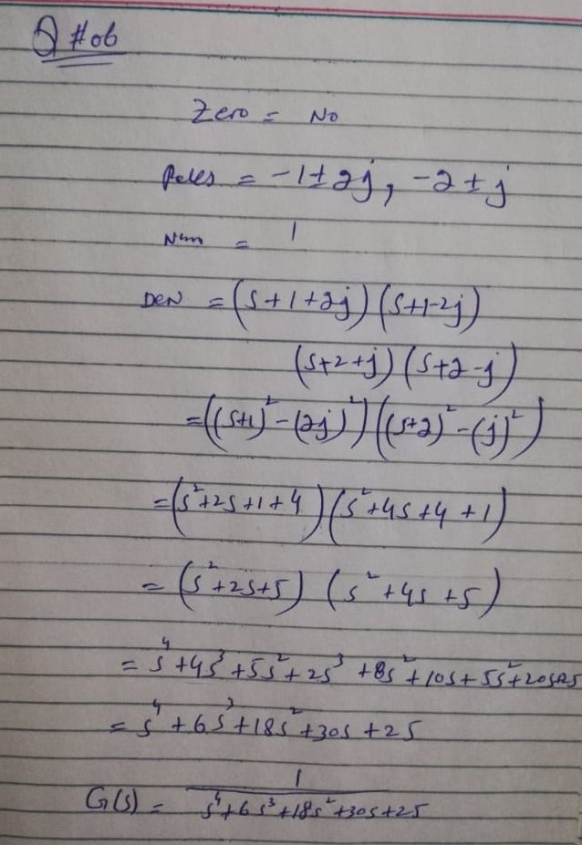

## Code

clc

clear all

close all

num=[1];

den=[1 6 18 30 25];

tf_=tf(num,den)

rlocus(tf_)

## Plot

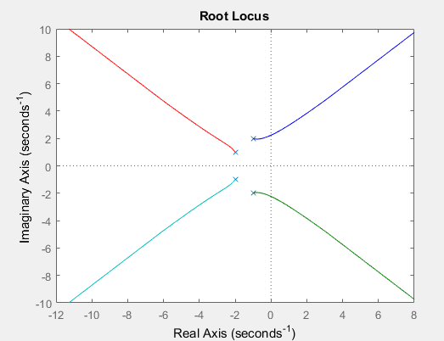

## Output

